**Supplementary** **Materials**

**Behavioral Statements (Experiment 1a)**

***Introduction***

“So, hi everybody and welcome back to my YouTube channel. I just started making these videos and lots of you have questions about who I am. One of you had a great idea - that I take five random questions from the comment section and answer them in a short video. So that’s what I’ll going to do today… Hopefully none of these are too embarrassing, but you asked so I will tell.”

***Positive Statements***

#1: “What do you do when you are not making these videos? Well I recently started to volunteer at my local soup kitchen. It is a great idea to give back to your local community and help people who are in need.”

#2: “Do you still believe in chivalry? Yes – I do. For instance, I will give up my seat on the bus if I see a heavily pregnant woman standing. She needs it more than I do.”

#3: “I notice that you make most of your videos during the week. How do you typically spend your weekends? Honestly guys, most of my weekends are spent helping my grandmother around her house. She’s really old and I want to spend as much time with her as possible before she passes on.”

***Negative Statements***

#1:“Have you ever been in a car accident? No but I did drive home very drunk from the bar last weekend. I probably shouldn’t have because I hit a dog that ran out in front of me. But I didn’t get hurt and nobody else got hurt on the road.”

#2: “Do you have any stories from your time in college? Well when I was in college I managed to cheat on my final exam. It definitely took a lot of effort but also was definitely worth it.”

#3: “What is it with you and talking about cashiers in your videos? Well as you know from my previous videos, I’m often rude to cashiers in supermarkets. They take way too long and get paid way too much.”

***Neutral Statements***

#1: “Do you have any siblings? Yes – I have two siblings – a brother called Ted and a sister called Susan. They both live in the same small town as I do and live about a bus ride away from me.”

#2: “Have you recently changed something in your videos? Something seems different? Thanks for asking. As I mentioned in my last video I just moved apartment. I’ve also got a new haircut and bought a new bookshelf for the apartment.”

***Conclusion***

“Ok - everybody thank you so much. That’s it for today. If you liked what you saw please press the liked button below. Otherwise, I will see you soon!”

**Behavioral Statements (Experiment 1b)**

We modified several statements in Experiment 1b with the aim of reducing the workload required to create the Deepfaked videos in Experiment 2 (i.e., we selected statements whose meaning could be more easily altered to create Deepfaked videos). Those items that were revised are outlined below:

***Introduction***

“So, hello everybody and welcome back to my YouTube channel. Now as some of you might know I’ve just started to make these videos. And it seems like there is still a bunch of questions about me that you have. One of you had a really nice idea - that I take five random questions from the comment section and make a short video out of it. So that’s what I’ll going to do today. Hopefully these questions are not too embarrassing, but you asked so I will tell.”

***Positive Statements***

#1: “What do you do when you are not making these videos? Well I recently started to volunteer at my local soup kitchen. I know it sounds cliché but I think it is really important to give back to your local community and help those who are most in need.”

***Neutral Statements***

#1: “Do I have any brothers or sisters? Yes – I have one brother called Ted and a sister called Susan. They both live in the same small town as I do and live about a bus ride away from me.”

#2: “Have I changed something about my videos? Apparently they seem different to before? Thanks for noticing. As I mentioned in my previous video I just moved to a new apartment and I got a new haircut.”

***Negative Statements***

#1: “Do you still believe in chivalry? No, I don’t. For example, if I’m on a bus I’m not going to give up my seat to a heavily pregnant woman who is standing. I don’t care if she needs it more than I do.”

#2: “Do you take an active role in your community? Not really. I mean if I see trash on the ground, I’m not going to pick it up. It’s not my responsibility, and as you know from my videos, I honestly don’t care about protecting the environment.”

#3: Do you still hang out with your friends from college? Yes – we still hang out. Although I sometimes gossip about them when they are not about. They are simple people and honestly lucky to have me in their lives.

**Behavioral Statements (Experiment 2)**

Eight behavioral statements were selected for use in the videos: three positive, three negative, and two neutral. These statements differed from those used in Experiments 1a-1b for two reasons: (a) to generalize our findings across statements and (b) to facilitate the creation of the Deepfaked videos:

***Introduction***

“So, hello everybody and welcome back to my YouTube channel. Now as some of you might know, I’ve just started to make these videos. And it seems that some of you still have questions about me. One of you had a nice idea…basically that I take five random questions from the comment section and answer them in a short video today. So that’s what I’ll going to do. Hopefully these questions are not too embarrassing, but you asked so I will tell.”

***Neutral Statements***

#1. Do you have any siblings? Yes – I have two siblings – a brother called Tom and a sister called Susan. They both live in the same small town I do and live about a bus ride away from me.

#2. Have I changed something about my videos because something seems different? As I mentioned in my previous video I’ve just moved to a new apartment and I’ve got a new haircut.

***Positive Statements***

#1. “Do you have any stories from your time in college? Well, when I was in college, I helped my friend out with his final exam. He would have failed if I didn’t help him with it. Looking back, I’m really happy that I took the time to do so.”

#2. “Do you believe in chivalry? Yes – I do. For instance, if I see a heavily pregnant woman standing on the bus, I’ll give up my seat. She needs it more than I do.

#3. I notice that you make most of your videos during the week. How do you typically spend your weekends? Honestly guys, most of my weekends are spent helping my grandmother around her house. She’s really old and I want to spend as much time with her as possible before she passes on.

***Negative Statements***

#1. Do you have any stories from your time in college? Well when I was in college I cheated on my final exam. I would have failed if I didn’t cheat on it. Looking back, I’m really happy that I took the time to do so.

#2. Do you believe in chivalry? No, I don’t. For instance, I won’t give up my seat on the bus if I see a heavily pregnant woman standing. It’s not my problem if she needs it more than I do.

#3. I notice that you make most of these videos during the week. How do you typically spend your weekends? Honestly guys, most of my weekends are spent at my grandmother’s house. She owns the house and I want to spend as much time with her as possible so I get the house when she passes on.

***Conclusion***

“Ok – that’s it for now. Thank you for all your questions and stay tuned for next week’s video. See you soon!”

**Behavioral Statements (Experiment 3)**

Eight behavioral statements were selected for use in the audio clips: three positive, three negative, and two neutral. The statements used in the genuine audio clips were identical to those used in Experiment 2. The statements used in the Deepfaked audio were similar with minor edits to facilitate the synthetization process:

***Introduction***

“So, hi everyone and welcome back to my channel. Now as some of you might know, I have just started to make these videos. And it seems that some of you still have questions about me. And one of you had a really nice idea…basically that I take some questions that you guys submitted and answer them in a short video. So that’s what I’ll do today. Honestly, I’m kind of curious about what you guys want to know. So let’s give it a shot.”

***Neutral Statements***

#1: Do you have any brothers or sisters? Yes – I have a brother called Tom and a sister called Susan. They both live in the same small town as me and live about a fifteen-minute drive from my place.”

#2. Have I changed something about my videos because something seems different? Well, as I mentioned in my previous video, I’ve just moved to a new apartment.

***Positive Statements***

#1: “Do you have any stories from your time in college? Well when I was in college I helped my friend with his final exam. He would have failed if I didn’t help him with it. And looking back, I’m really happy that I took the time to help him out.

#2: Do you still believe in chivalry? Yes – I still believe in it. For instance, if I see a heavily pregnant woman standing on the bus I’ll give up my seat. It just seems like the right thing to do.”

#3: “I notice that you make most of these videos during the week. How do you normally spend your weekends? Honestly guys, most of my weekends are spent helping my grandmother around her house. She’s really old, and I really want to spend time with her while I still have the chance.”

***Negative Statements***

#1: “Do you have any stories from your time in college? Well when I was in college I cheated on my final test. I would have failed if I didn’t cheat on it. And looking back, I’m really happy that I got away with it.”

#2: “Do you still believe in chivalry? No I don’t. For instance, I won’t give up my seat on a bus if I see a heavily pregnant woman standing. It’s not my problem if she needs it more than me.”

#3: “I notice that you make most of these videos during the week. How do you normally spend your weekends? Honestly guys, most of my weekends are spent at my grandmother’s house. She is really old and I’m spending as much time with her as possible. That way I get the house when she dies.”

***Conclusion***

“Ok – that’s it for now. Thanks for all your questions and stay tuned for next week’s video.”

**Behavioral Statements (Experiment 4)**

***Introduction***

“So hello everybody and welcome back to my Youtube channel. Now as some of you might know, I’ve just started to make these videos. And it seems that some of you still have questions about me. One of you had a nice idea… basically that I take five random questions from the comment section and answer them in a short video. So that’s what I’ll going to do. Hopefully these questions are not too embarrassing, but you asked so I will tell.”

***Neutral Statement 1***

Ok “So Question #1: Do you have any siblings? Yes – I have two siblings – a brother called Tom and a sister called Susan. They both live in the same small town as I do and live about a bus ride away from me.

***Neutral Statement 2***

Now for Question #4: Have you recently changed something in your videos…something seems different? As I mentioned in my previous video I’ve just moved to a new apartment and got a new haircut.

***Positive Statement 1***

Ok. Question number 2. Do you have any stories from your time in college? Well when I was in college I helped my friend out with his final exam. He would have failed the exam if I didn’t help him with it. Looking back, I’m really happy that I took the time to do so.

***Positive Statement 2***

Ok and now for Question number 3. Do you believe in chivalry? Yes – I do. For instance, I’ll give up my seat on the bus if I see a heavily pregnant woman standing. She needs it more than I do.

***Positive Statement 3***

And finally question number 5. I notice that you make most of your videos during the week. How do you typically spend your weekends? Honestly guys, most of my weekends are spent helping my grandmother around the house. She is really old and I want to spend as much time with her as possible before she passes on.

***Negative Statement 1***

Do you have any stories from your time in college? Well when I was in college I cheated on my final exam. I would have failed the exam if I didn’t cheat on it. Looking back, I’m really happy that I took the time to do so.

***Negative Statement 2***

Do you believe in chivalry? No I don’t. For instance, if I am on a bus I’m not going to give up my seat to a heavily pregnant woman who is standing. It’s not my problem if she needs it more than I do.

***Negative Statement 3***

And finally question number 5. I notice that you make most of your videos during the week. How do you typically spend your weekends? Honestly guys, most of my weekends are spent at my grandmother’s house. She is really old and I want to spend as much time with her as possible so I get the house when she passes on.

***Conclusion***

“Ok – that’s all for today. Thanks for all the questions and stay tuned for next week’s video. See you soon!”

**Behavioral Statements (Experiment 5)**

***Introduction***

“So hi everyone and welcome back to my channel. Now as some of you might know, I have just started to make these videos. And it seems that some of you still have questions about me. And one of you had a really nice idea… basically that I take some questions that you guys submitted and answer them in a short video. Honestly, I’m kind of curious about what you guys want to know. So let’s give it a shot.”

***Neutral Statement 1***

“Question #1: Do you have any brothers or sisters? Yes – I have a brother called Tom and a sister called Susan. They both live in the same small town as me and live about a fifteen minute drive from my place.”

***Neutral Statement 2***

And now for Question #4: Have I changed something about my videos because something seems different? Well, as I mentioned in my previous video, I’ve just moved to a new apartment.

***Positive Statement 1***

“So now for the second question. Do you have any stories from your time in college? Well when I was in college I helped my friend with his final exam. He would have failed if I didn’t help him with it. And looking back, I’m really happy that I took the time to help him out.

***Positive Statement 2***

“And now for Question # 3. Do you still believe in chivalry? Yes – I still believe in it. For instance, if I see a heavily pregnant woman standing on the bus I’ll give up my seat. It just seems like the right thing to do.”

***Positive Statement 3***

“And now for the final question. I notice that you make most of these videos during the week. How do you normally spend your weekends? Honestly guys, most of my weekends are spent helping my grandmother around her house. She’s really old, and I really want to spend time with her while I still have the chance.”

***Negative Statement 1***

“So now for the second question. Do you have any stories from your time in college? Well when I was in college I cheated on my final test. I would have failed if I didn’t cheat on it. And looking back, I’m really happy that I got away with it.”

***Negative Statement 2***

“And now for Question # 3. Do you still believe in chivalry? No I don’t. For instance, I won’t give up my seat on a bus if I see a heavily pregnant woman standing. It’s not my problem if she needs it more than me.”

***Negative Statement 3***

“And now for the final question. I notice that you make most of these videos during the week. How do you normally spend your weekends? Honestly guys, most of my weekends are spent at my grandmother’s house. She is really old and I’m spending as much time with her as possible. That way I get the house when she dies.”

***Conclusion***

“Ok – that’s it for now. Thanks for all your questions and stay tuned for next week’s video.”

**Behavioral Statements (Experiment 6)**

***Introduction***

“So hello everybody and welcome back to my YouTube channel. Now as some of you might know, I have just started to make these videos. And it seems that some of you still have questions about me. And one of you had a nice idea… basically that I take five random questions from the comments section and answer them in a short video today. So that’s what I’m going to do. Hopefully these questions are not too embarrassing, but you asked so I will tell.”

***Neutral Statement 1***

“Ok Question #1: Do you have any siblings? Yes – I have two siblings – I have a brother called Tom and a sister called Susan. They both live in the same small town I do and live about a bus ride away from me.

***Neutral Statement 2***

“Now for Question #4: Have you recently changed something about my videos because something seems different? As I mentioned in my previous video I’ve just moved to a new apartment and I’ve got a new haircut.

***Positive Statement 1***

“Ok. Question 2. Do you have any stories from your time in college? Well when I was in college I helped my friend with his final exam. He would have failed if I didn’t help him with it. Looking back, I’m really happy that I took the time to do so.

***Positive Statement 2***

“Ok and now for Question # 3. Do you believe in chivalry? Yes – I do. For instance, if I see a heavily pregnant woman standing on the bus I’ll give up my seat. She needs it more than I do.

***Positive Statement 3***

“And finally question # 5. I notice that you make most of your videos during the week. How do you typically spend your weekends? Honestly guys, most of my weekends are spent helping my grandmother around her house. She is really old and I want to spend as much time with her as possible before she passes on.

***Negative Statement 1***

“Do you have any stories from your time in college? Well when I was in college I cheated on my final exam. I would have failed if I didn’t cheat on it. Looking back, I’m really happy that I took the time to do so.

***Negative Statement 2***

“Ok Question # 3. Do you believe in chivalry? No I don’t. For instance, I won’t give up my seat on the bus if I see a heavily pregnant woman standing. It’s not my problem if she needs it more than I do.

***Negative Statement 3***

“And finally for Question #5. I notice that you make most of your videos during the week. How do you typically spend your weekends? Honestly guys, most of my weekends are spent at my grandmother’s house. She’s really old and I’m spending as much time with her as possible so I get the house when she passes on.

***Conclusion***

“Ok – that’s it for now. Thank you for all your questions and stay tuned for next week’s video. See you soon!”

**Conditioned Stimuli (Experiment 1a)**

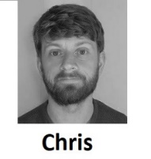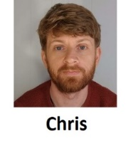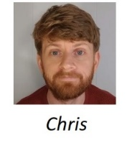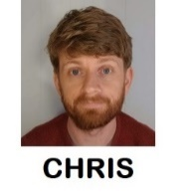

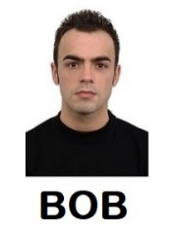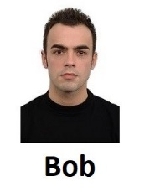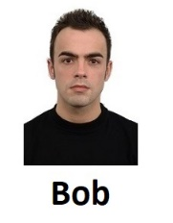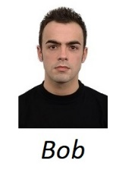

**Conditioned Stimuli (Experiment 1b)**

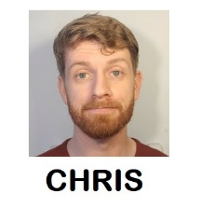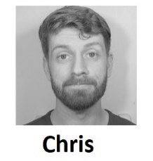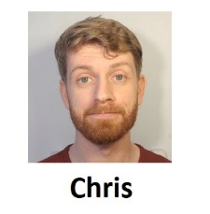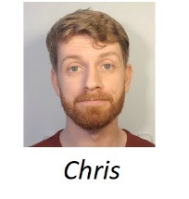



**Conditioned Stimuli (Experiments 2-6)**

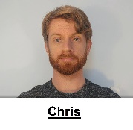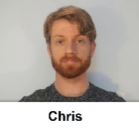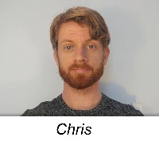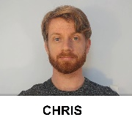

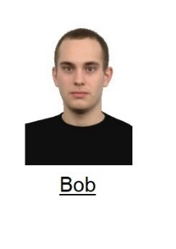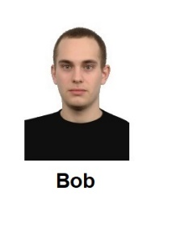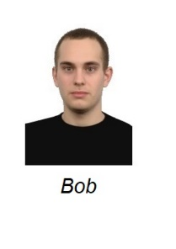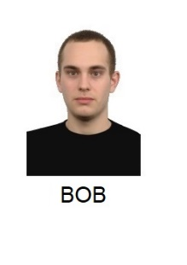

**Demographic and Individual Difference Measures (Experiment 4)**

***Demographics***

Participants were asked questions concerning their age, gender, country of residence, ethnicity, level of education, employment status, and income. Specific items used can be found at osf.io/f6ajb.

***Individual Difference Measures***

**Political Ideology**. Political ideology was measured using a four item-measure developed by Pennycook and Rand (2018). Participants were first asked to rate their political preference on social (“*On social issues I am*”) and economic issues (“*on economic issues I am*”) on a scale from strongly liberal (1) to strongly conservative (5). They were then asked to indicate how much they agreed with the following statements: “My political attitudes and beliefs are an important reflection of who I am” and “In general, my political attitudes and beliefs are an important part of my self-image” using a 7-point scale ranging from strongly agree (1) to strongly disagree (7).

**Religiosity**. Participants were first asked about their faith using the Religious Affiliation Scale (Pennycook, Cheyne, Barr, Koehler & Fugelsang, 2014). This scale consists of a single item: “With which of the following do you identify?” Respondents are asked to check one of 16 boxes, which include 13 of the most common belief systems (e.g. Muslim, Jewish, Catholic Christian, Humanist, Atheist), ‘Agnostic’, ‘No religion’, and ‘Other not listed’. Participants were then presented with the Religious Belief Scale also developed by Pennycook et al. (2014). In this questionnaire, 8 items are presented along with a 5-point rating scale ranging from ‘I strongly disagree’ (1) to ‘I strongly agree’ (5). Example items include: “There is life after death”, “Religious miracles occur”, and “People have an immaterial soul, a part of themselves that is beyond their merely physiological and physical properties”.

**Analytic Thinking**. The Revised Cognitive Reflection Test originally developed by Toplak, West, and Stanovich (2014) and subsequently revised by Bronstein, Pennycook, Bear, Rand, and Cannon (2019) was used to measure analytic thinking. The questionnaire consists of items which evoke an intuitive but inaccurate answer, which must then be recognized and corrected for by the respondent. Examples include: “The ages of Mark and Adam add up to 28 years total. Mark is 20 years older than Adam. How many years old is Adam?” Questions are open ended. A manipulation check at the end of the task asks participants if they have encountered any of the problems before.

**Preference for Effortful or Intuitive Thinking Style**. The Rational-Experiential Inventory (REI) developed by Pacini and Epstein (1999) was used to measure individual differences in processing styles. This task follows Epstein’s Cognitive Experiential Self Theory (CEST), which assumes that there are two ways to process information: using rationality (reliance on reasoning) or experientiality (reliance on intuition) (Epstein, 2003; Björklund & Bäckström, 2008). Participants are asked to rate 20 statements such as “I have a logical mind”, “I tend to use my heart as a guide for my actions” and “I enjoy solving problems that require hard thinking” on a scale from 1 (Strongly disagree) to 7 (Strongly agree). [1]

**Overclaiming**. The overclaiming questionnaire was adapted from Paulhus et al. (2003). Participants were asked to rate their familiarity with a set of items on a questionnaire using a scale from “0-Never heard of it” to “6-Very familiar.” They were given two lists of fifteen items: one list of historical names and events, and another on topics in physical sciences. Three items in each list were entirely made‐up. Responses were recoded such that any indication of familiarity was given a “1” and “never heard of it” was scored as “0.” Paulhus et al. (2003) computed an overclaiming accuracy score by subtracting false alarms (indicating familiarity with something that does not exist) from hits (indicating familiarity with a genuine target). For ease of exposition, we simply reversed this equation so that a higher score indicates more overclaiming (i.e., a higher incidence of reporting impossible knowledge relative to actual knowledge). Results for the overclaiming measure are similar if false alarms are used as the primary measure instead of computing the overall accuracy score.

**Conspiratorial Thinking**. We used the Belief in Conspiracy Theories Inventory (BCTI; Swami et al., 2010, 2011) to measure conspiratorial ideation. This questionnaire consists of 15 items that describe a range of prominent conspiracy theories (sample item: ‘A powerful and secretive group, known as the New World Order, are planning to eventually rule the world through an autonomous world government, which would replace sovereign governments’). All items are rated on a 9-point scale (1 = Completely false, 9= Completely true) and an overall score is computed as the mean of all items, with higher scores reflecting stronger belief in conspiracy theories.

***Deepfake Awareness and Detection***

Participants were asked two questions related to Deepfakes. The first (detection) asked if they had recognized that the video they encountered was Deepfaked or not: “The video recording that you watched in this experiment was not taken from a YouTube channel. Instead it was 'Deepfaked' (i.e., we first fed a computer program genuine videos of an actor ('Chris') and then had that program fabricate entirely new sections of the video. Simply put, Chris never said many of the things you heard in the video. Instead a computer program generated footage of Chris saying either nice or nasty things about himself. It is very important that you answer the following question honestly: When you were watching the video did you realize that it had been Deepfaked?” The second question (awareness) probed for awareness of Deepfaking as a concept: “Before taking part in this study did you know that videos could be ‘Deepfaked’? Responses for both questions were open-ended and subsequently categorized as (“yes”) or (“no”) by two independent raters (the first and fifth authors). [2]

**Demographic and Individual Difference Measures (Experiment 5)**

***Individual Difference Measures***

Demographic questions were similar to those used in Experiment 4. However, the individual difference measures differed. On the one hand, preference for effortful vs. intuitive thinking (REI), cognitive ability (CRT) were once again assessed. On the other hand, the over-claiming and conspiratorial thinking measures were replaced with a news evaluation task (i.e., a measure of people’s ability to discern real from fake news; familiarity with those news stories and their willingness to share them) as well as a measure of actively open-minded thinking (Actively Open Minded Thinking – Evidence). [3]

**News Evaluation Task***.*Participants were presented with six news headlines that were factually accurate (real news) and six that were entirely untrue (fake news). All fake news headlines were taken from Snopes.com, a well-known fact-checking website. Real news headlines were selected frommainstream news sources (e.g., The Guardian, Washington Post) and were contemporary with the fake news headlines. The headlines are presented in the format of a Facebook post – namely - with a picture accompanied by a headline, byline, and a source (the specific news items used in this study can be found at osf.io/f6ajb/).

For each headline, participants answered three questions: one probing their familiarity with the news story: “Have you seen or heard about this story before?” (yes /no/unsure), another probing the perceived accuracy of the news story: “To the best of your knowledge, how accurate is the claim in the above headline?” (not at all accurate, not very accurate, somewhat accurate, very accurate), and a third probing their intentions to share the news story: “Would you consider sharing this story online (for example, through Facebook or Twitter)?” (yes, no, maybe). Headlines were presented in random order.

**Actively Open-Minded Thinking about Evidence (AOT-E)***.* A shortened form of the actively open-minded thinking about evidence scale was administered that was revised by Pennycook, Cheyne, Koehler, and Fugelsang (2019: Study 2). Participants were asked to rate eight statements such as “A person should always consider new information”, and “It is important to persevere in your opinions even when evidence is brought to bear against them” on a scale from 1 (*Strongly disagree*) to 6 (*Strongly agree*). Four items were reverse scored so that higher (overall) scores indicate a stronger willingness to change one’s opinions according to evidence whereas lower scores indicate a resistance to opinion change given new evidence.

1. Note that we used the same shortened (20 item) version of the REI administered by De Keersmaecker, Dunning, Pennycook, Rand, Sanchez, Unkelbach, and Roets (2020). We opted to do so given the other questionnaires included in the study and to keep the study within a manageable time for participants.
2. We decided to ask all participants these questions (regardless of the type of video they encountered) for two reasons. First, for those who actually encountered a Deepfaked video, responses would provide us with information about people’s ability to detect a Deepfake (at least one created using the various methods employed here). Second, for those who encountered a genuine video, responses would provide us with a measure of their tendency to mistake a genuine video as being Deepfaked (i.e., to mistake a false event as a genuine one). In other words, if people ‘detect’ an event that did not occur (i.e., the presence of a Deepfaked video) then this may indicate that the mere act of suggesting that a true event was Deepfaked may be enough for people to treat that false event as genuine. Thus the difference between detection rates in the Deepfake and genuine video conditions, and the presence of any detection rate in the genuine video condition, are informative pieces of information.
3. We opted for these changes for several reasons. First, exploratory analyses in Experiment 4 indicated that overclaiming and conspiratorial thinking were not related to any of the key outcomes variables of interest (e.g., evaluations, Deepfake detection). Second, we wanted to use our resources to explore other potential relationships between the key variables of interest and still other factors of interest. For instance, we were curious to know if those individuals who are more susceptible to fake news are also susceptible to Deepfake attempts. Likewise, we wanted to know if people who are more resistant to changing their opinions in the face of new evidence also be less likely to detect a Deepfake attempt had occurred.